Feedback for the online tool

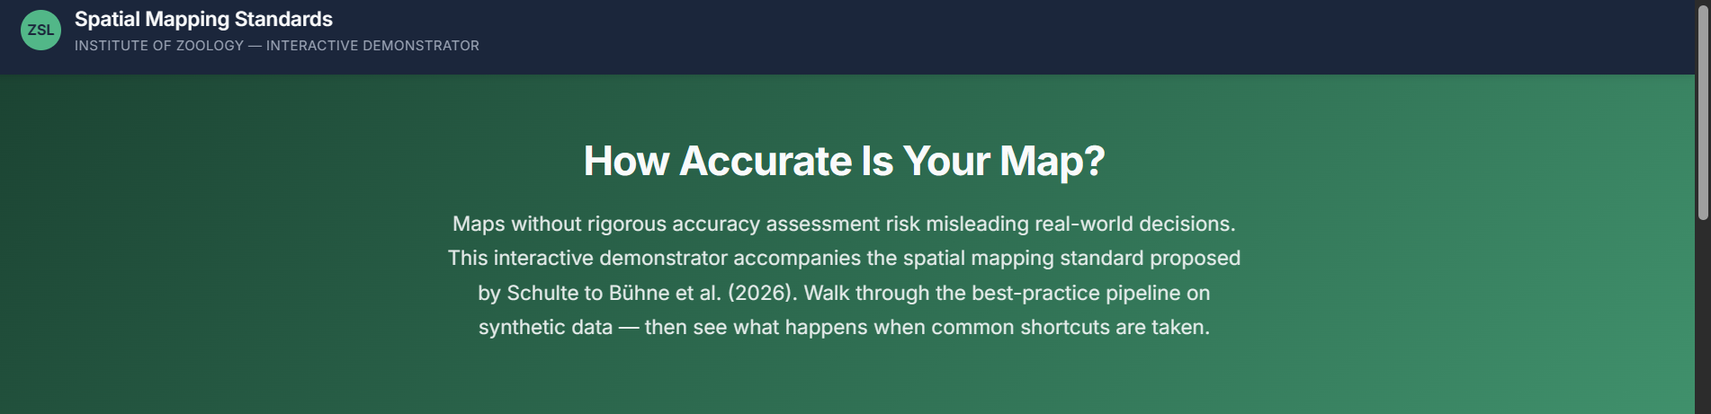
Love this! Minor suggestions:
- Can we change “Spatial Mapping Standards” to “Conservation Map Standards” for consistency with the wording used in the manuscript?
- I assume you were planning for this anyways, but will we add a link to the paper? (Or just link to the reference at the bottom of the page)
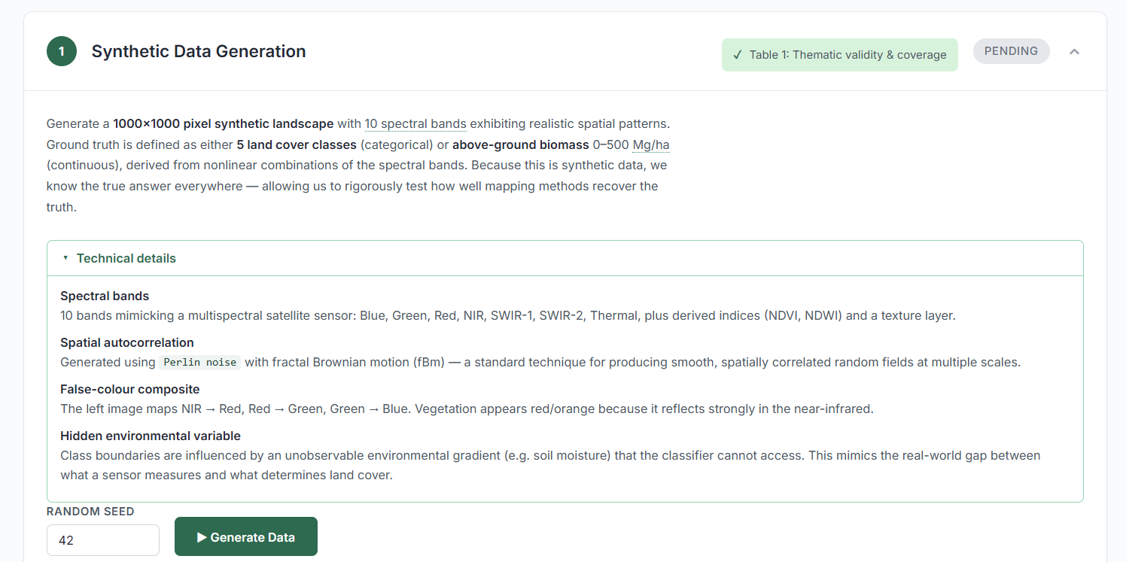
I really like the collapsable technical details pane. I personally would prefer moving the current wording description (everything from “Generate…”) into that section, and simplifying the description that is immediately visible to the user even more, e.g.:
- “First, we generate satellite imagery for an artificial landscape (1000 by 1000 pixels). The satellite imagery has 10 bands (similar to many open-source satellite sensors), and realistic spatial relationships of reflectance values. We also generate the variable that we want to map – either land cover, or aboveground biomass, through combining the artificial satellite bands, and adding noise [is this true?]. This means that we know what the groundtruth is at every point on this map, and can determine how well any map derived from the satellite imagery reflects it.”
- What unseen variables affect the biomass variable? Or is that a combination of satellite data without noise or anything unobserved?
- What does the green box (“Table 1:…”?) stand for? Can we replace with “Generate synthetic landscape” or “Generate artificial landscape”? (I think we should take out references to the Table because people don’t know that the table is the central organisational principle for the standard, and they don’t need to know really – unless I am missing something?)
- “Random seed”: Can we add a short description for non-experts (e.g. “change this to any number of your choosing to generate different synthetic data”)
- Very optional: Can we give people a choice about how good the satellite data is at capturing the feature of interest? (I.e. can we let them choose the level of noise?)
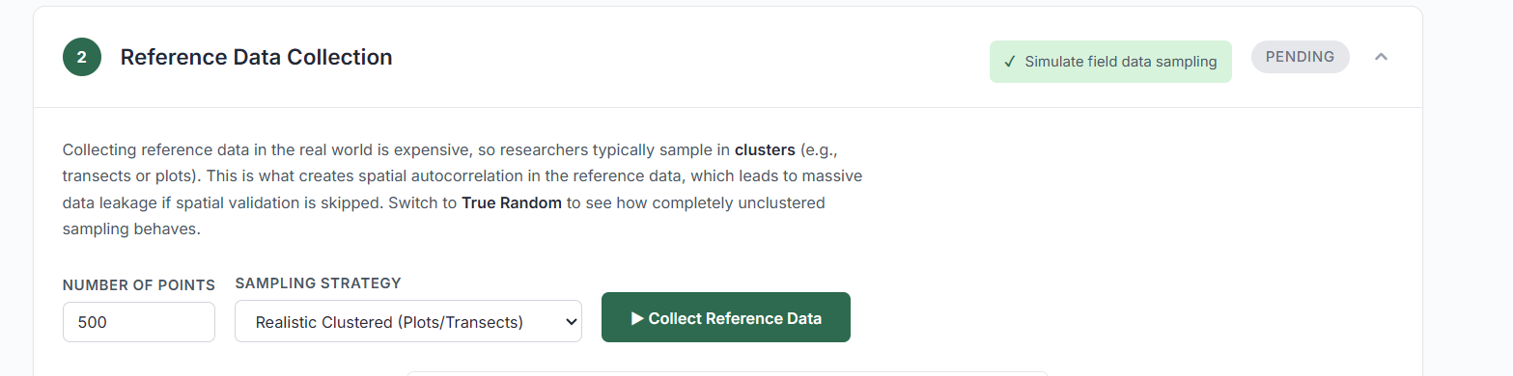
- Suggested changes: “Collecting reference data in the real world is expensive, so researchers typically sample in clusters (e.g., transects or plots). This is what creates spatial autocorrelation in the reference data, which – if not dealt with during the validation process (see step 3) – leads to overestimating the map accuracy, and thus can lead to accepting maps that are not sufficiently accurate.. Switch to True Random to see how completely unclustered sampling looks like.”

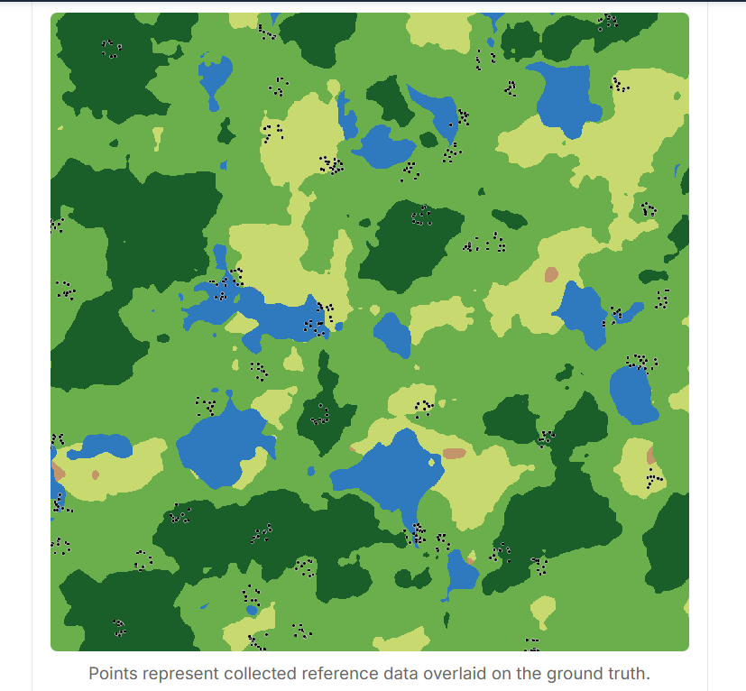
​​
- Can the points be larger? (Or crosses?)
- Also I think we need to pick between groundtruth and reference data (I know for synthetic data we can actually speak of groundtruth, but shall we use reference data, or validation data when specifically talking about validation steps, and save us the comments about “oh but it isn’t really groundtruth bla bla bla”?)

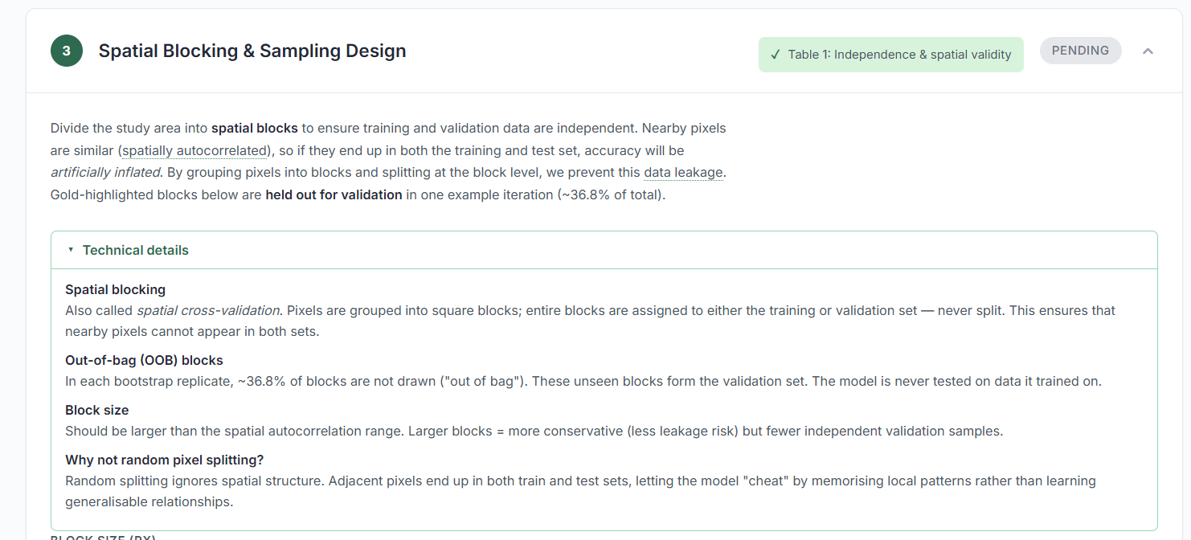

- Could you add a note about why you chose 36.8% of the data as the cut-off?
- Optional: Could we allow people to choose this threshold themselves?

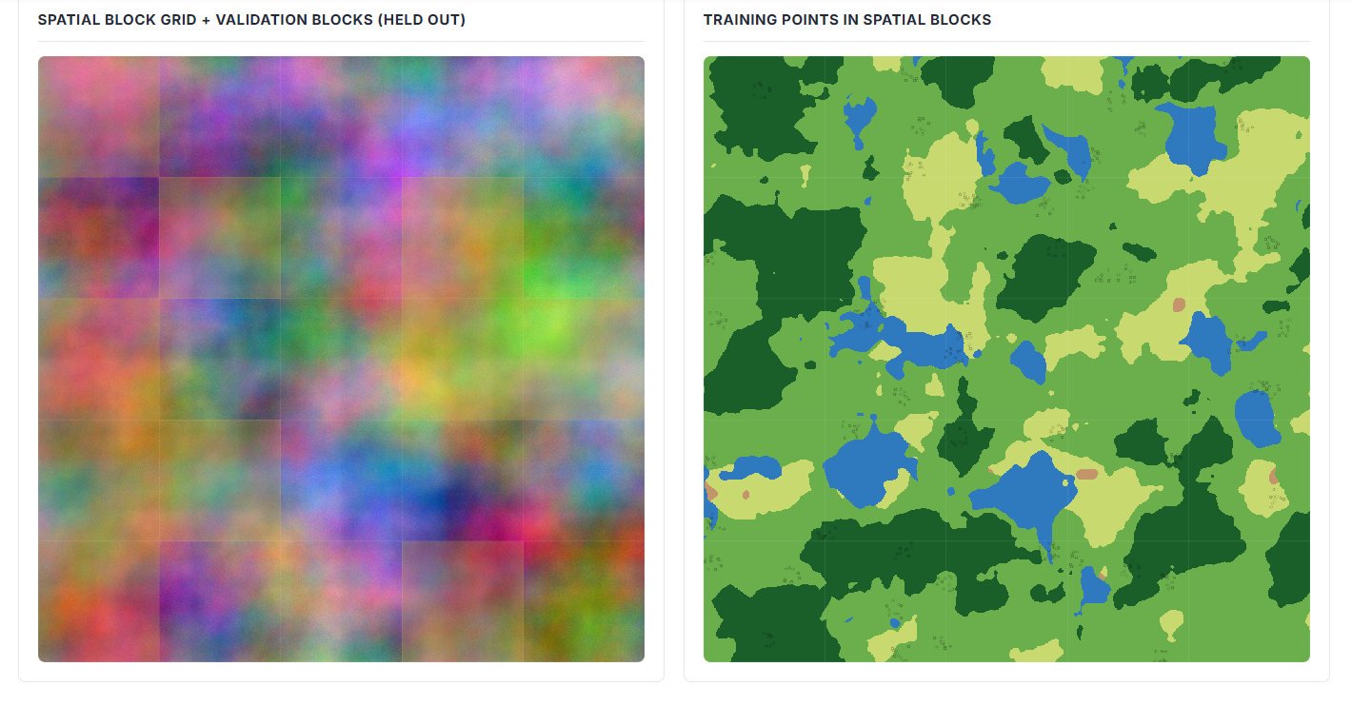
- Would it be possible to make the grid lines ticker? I find them hard to see

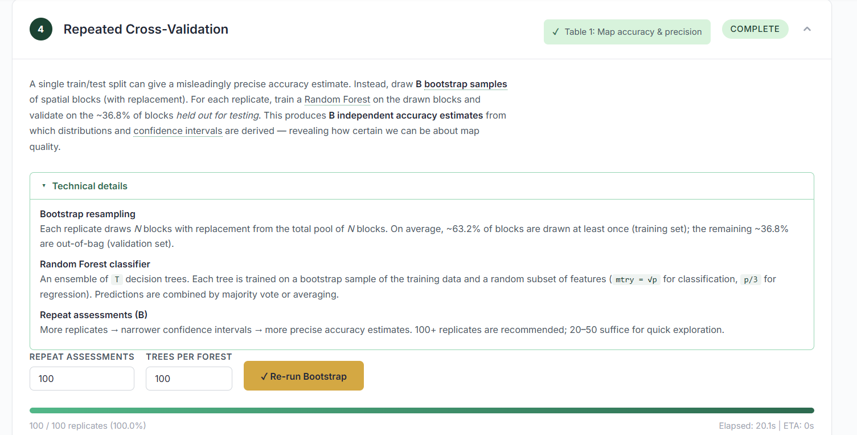

- I would alter the title to “Model training with repeated cross-validation” to clarify where the model training takes place.
- Suggested edits for main text: “Reference data are split into training and validation data. Models, such as a Random Forest algorithm we use here, learn the relationship between the satellite data and the training data. After the model is trained, we can then check how good it is at predicting land cover classes or biomass values for locations that it has not seen during the training process. This is important to ensure that the model has learned real relationships between input data and training data, not random associations. A single train/validation split can give a misleading accuracy estimate (overoptimistic or overpessimistic). Instead, it is best practice to draw B bootstrap samples of spatial blocks (with replacement). For each replicate, train a Random Forest on the reference data in the selected blocks and validate on the ~36.8% of blocks held out for validation. This produces B independent accuracy estimates from which distributions and confidence intervals are derived — revealing how certain we can be about map quality.

Bootstrap resampling
A bootstrap sample is created by choosing, at random, a set number of blocks with replacement from the total pool of N blocks. This means that some blocks may be chosen several times. This process is repeated several times (often in the order of 100 and 1000s of times) to create a collection of samples. On average, ~63.2% of blocks are drawn at least once (training set); the remaining ~36.8% are the validation set (“out-of-bag”).
Random Forest classifier
A machine-learning algorithm that can learn non-linear relationships between input data (such as satellite data) and a response variable (such as a land cover, or biomass) using training data. It is made up of an ensemble of T decision trees. Each tree is trained on a bootstrap sample of the training data and a random subset of features (mtry = √p for classification, p/3 for regression). Predictions are combined by majority vote or averaging.
Repeat assessments (B)
More replicates means more sets of different combinations of training data, which results in narrower confidence intervals, and so more precise, accuracy estimates. 100+ replicates are recommended; 20–50 suffice for quick exploration.”

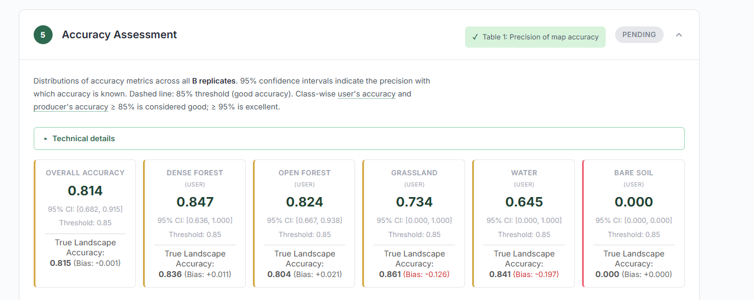
I really like the explanations for the accuracy metrics
- Suggested edits: “Accuracy metrics such are a key tool for map users to assess how reliable a map is. The bootstrapping process explained earlier generates B estimates of accuracy metrics, one for each bootstrap sample, so the distributions of accuracy metrics can be inspected. 95% confidence intervals indicate the precision with which accuracy is known. Dashed line: 85% accuracy threshold (good accuracy). Class-wise user's accuracy and producer's accuracy: ≥ 85% is considered good; ≥ 95% is excellent.”

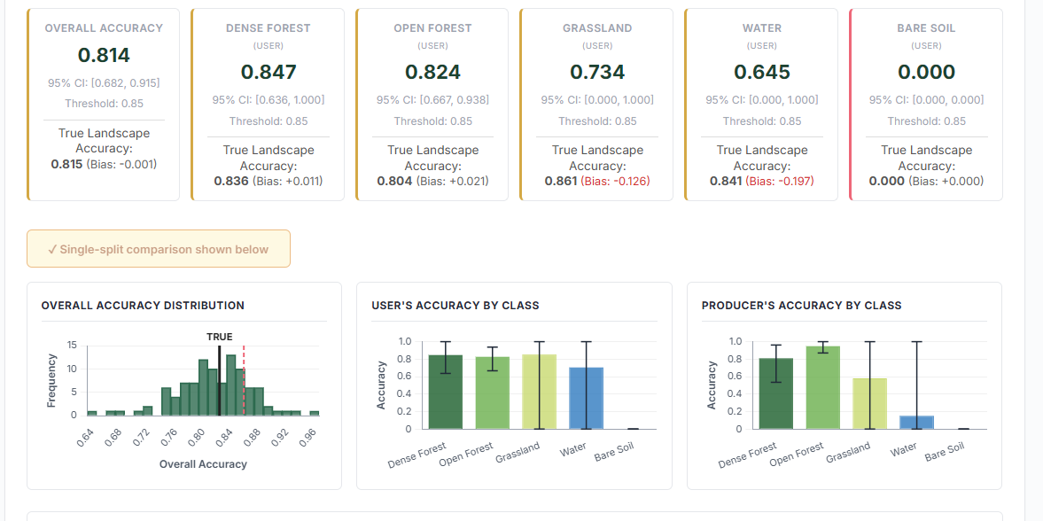
- I think this is visually quite dense – could we perhaps present the plots first, and then have an expandable section labelled “Accuracy estimates (additional information)” that contains the accuracy metrics cards?
- Could there be a label for the red dotted line? And a red dotted line labelled “good accuracy” or similar to the producer and user accuracy plots?
- Could we add an explainer about the meaning of larger confidence intervals? E.g. “A large confidence interval around a high accuracy metric means that we cannot say confidently that the accuracy metric truly is high. The smaller the confidence interval, the more certain we can be that a map created by a single model drawn from this sample gives a reliable representation of the truth”.
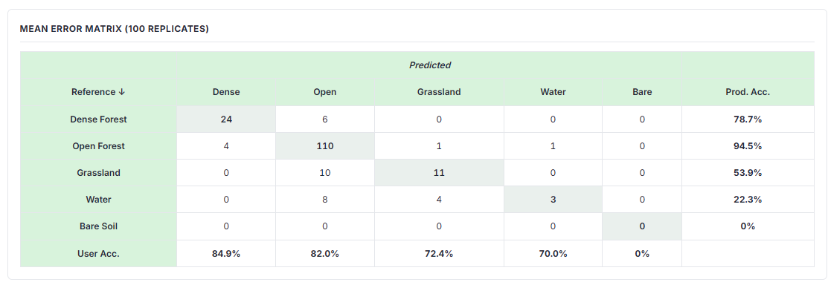
- I think this needs a short explainer of how the mean error matrix is created from the B samples
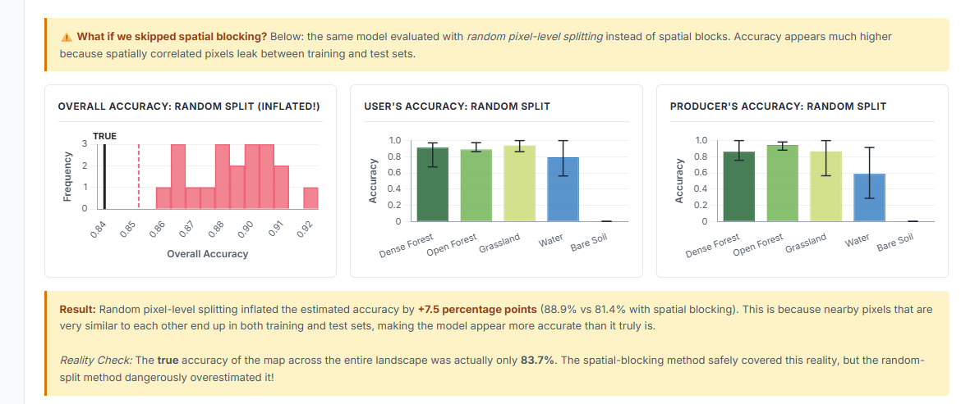
- YMMV for the use of the word “dangerous” but my vote would be to replace it with “Reality Check: The true accuracy of the map across the entire landscape was actually only 83.7%. The spatial-blocking method safely covered this reality, but the random-split method seriously overestimated overall accuracy, and gave the impression that we know user and producer accuracy with more confidence than we actually do.”
This whole section is so good!!

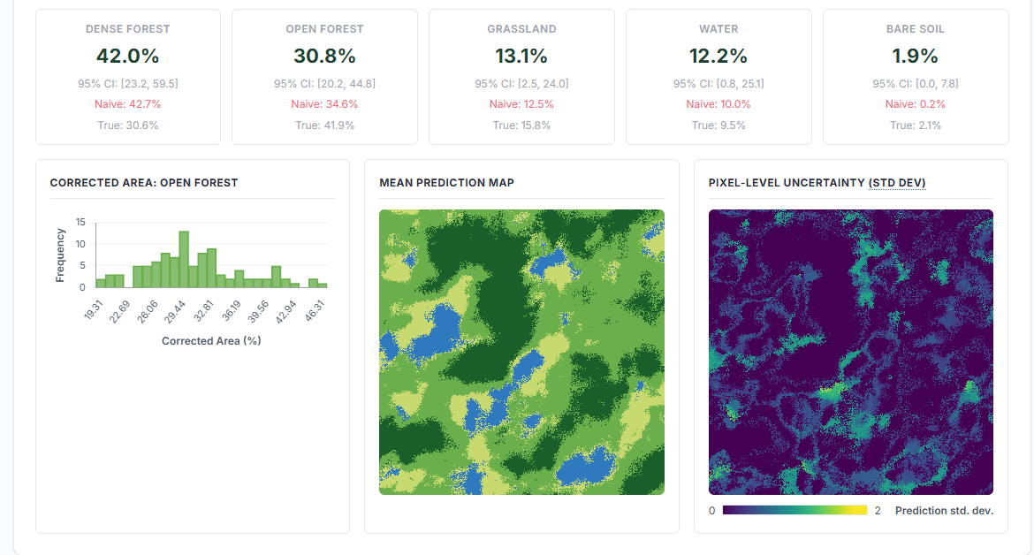
- I think this way of presenting the summary stats obscures the most important takeaway, namely the huge confidence intervals for rare or poorly-constrained classes. Could we have plots instead?
- It would also be good to explicitly say: “Large confidence intervals mean that we have very little idea of the true value, with confidence intervals sometimes spanning orders of magnitude. Over- or underestimating map-derived variables, such as the extent of forest or total biomass, to this extent is likely to have significant implications for conservation decisions or downstream analyses that use this data”
- I think the dotted red line (known open forest area) is missing here
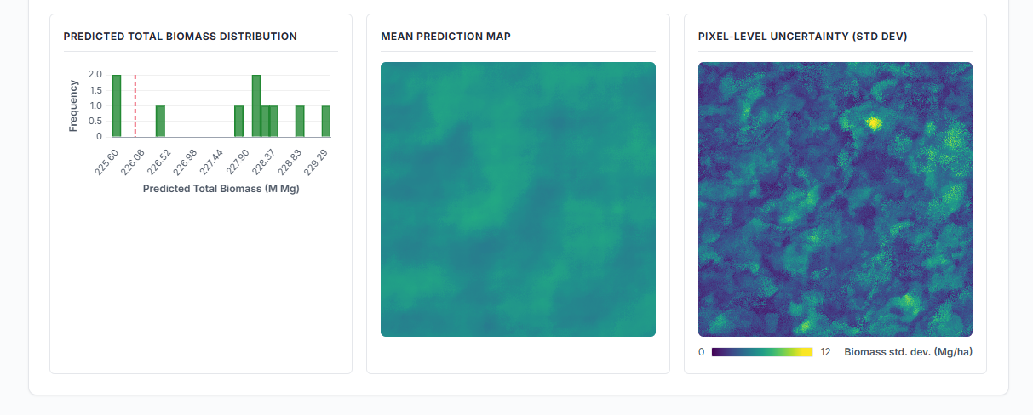
- Add a label to the dotted red line
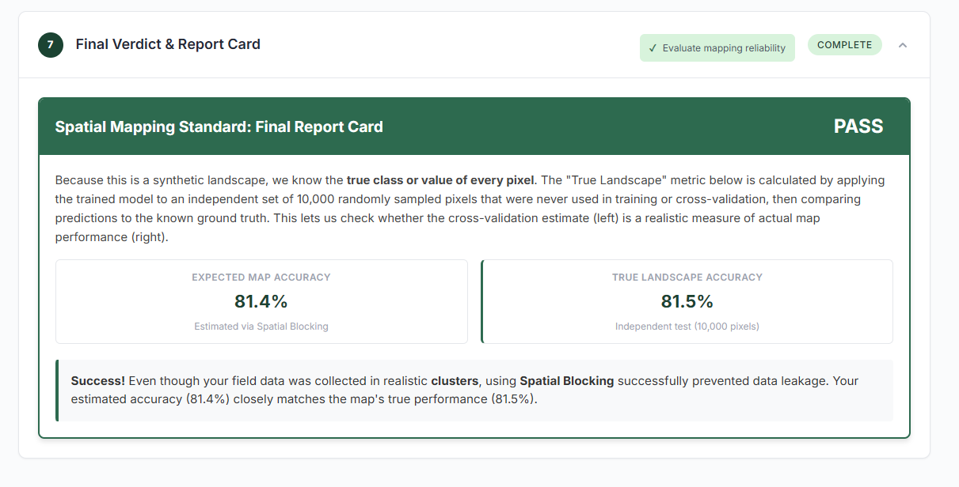
I love this. 10/10. No notes.
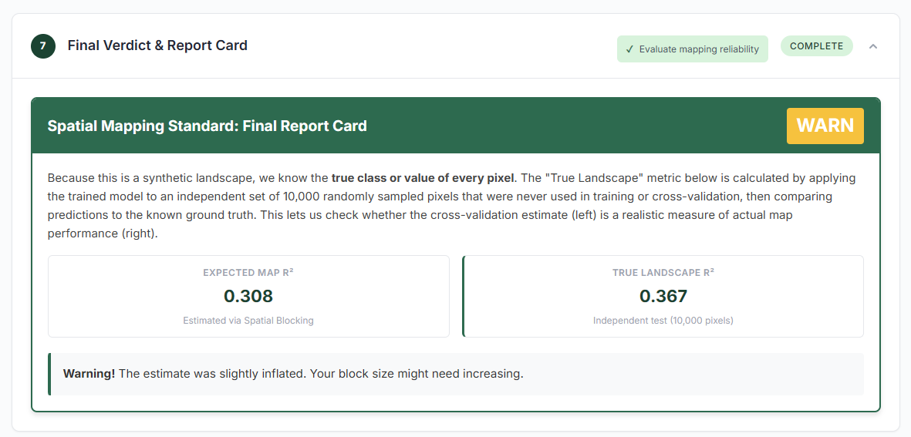
- (This is for a biomass iteration). I believe this should read “R2 was underestimated compared to the true Landscape R2”, right? For reference, I tried a version where I had only 100 reference points – I was trying to create a scenario where my confidence intervals were large despite using a solid sampling strategy

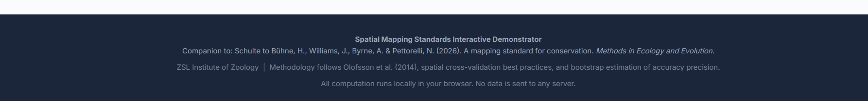
- Can we change “Spatial Mapping Standards” to “Conservation Map Standards” for consistency with the wording used in the manuscript?
- “Methodology follows …” we can just say “see our paper for additional information about best validation practice demonstrated here”
- Can we add “Demonstrator code base: https://github.com/J-Cos/conservation-mapping-standards. User interface was developed by a fully agentic workflow, unit-tested, and human-validated” or similar. I think we should name the agent as well!

